**Simplify your life with the Custom US Keyboard**

Note: this article is written as a promotion for my Github project at: https://github.com/frankliu197/Compose and written to be a tutorial like other articles on this blog.

**Introduction**

This keyboard is designed as an extension to the default US keyboard, adding the functionality of typing special characters such as Latin/Greek characters, mathematics and physics symbols. No keys and/or key combinations from the original US keyboard have been changed. It can only be used on Linux.

Here are the following additions:

* Type any combination of the following accents: acute, breve, caron, cedilla, circumflex, diaeresis, grave, macron, tilde

ẍ, ṕ, ṻ and even ǖ

* Type all Greek letters

υ, α, β

* Type many math symbols, more than you probably need (create a pull request if I am missing any)

≡, ∀, ≋, ≩, ⊊, ∰, ¾

* Type superscripts and subscripts

⁴, ⁺, ₀

* Type possibly useful symbols

¥, ¶, µ, ¿, °

Usage and installation explanations will be explained below.

**Usage**

This keyboard features four levels of key shifting. It means that you can type four different characters per key on your keyboard. Let’s take a look at an example below:

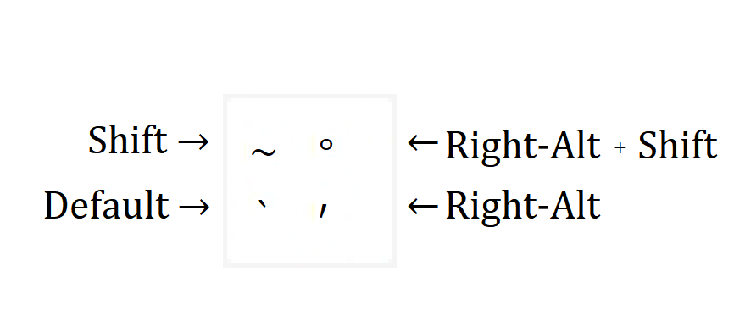

This is the custom keyboard’s implementation of the most upper-left key of your keyboard. By default, by pressing this key, you will print out the ` (grave) symbol. You can print out the ~, **°**,and′ symbols by pressing any sort of modifier key(s), which are:

* The shift key
* The third level shift key (which by default is the Right-Alt)
* And the second and third level shift key combined

Below is a quick reference of the key mappings of the keyboard. It is not required to know where all the keys are to effectively use this keyboard.

Note: You can display this keyboard layout on your computer by typing: gkbd-keyboard-display -l ,custom_us on the terminal.

You will notice that this keyboard contains almost no keys that I have specified in the introduction. Most of these keys are written though the dead keys (as shown in gray above), or the compose key, which is explained later.

Here are a few quick points about the keyboard’s layout:

* A comprehensive list of accents is found in the third and fourth level shift on the right side of the keyboard, where the punctuations are. You can use these accents with the compose key to properly other non-English Latin characters.
* The dead keys are found in the third and fourth level shift, on the right side of the keyboard.

**Dead Keys:**

Dead keys are similar to a modifier key (like shift), but they only create one type of characters:

**Dead Inverted** (Right-Alt + -)

Inverts the keys upside down

dead_inverted + A → ∀

**Dead Superscript** (Right-Alt + \)

Changes the next letter into its superscript form

dead_superscript + 1 → ¹

**Dead Subscript** (Right-Alt + |)

Changes the next letter into its superscript form

dead_subscript + 1 → ₁

**Dead Music** (Right-Alt + _)

Maps musical keys

dead_music + e → ♪ (eighth note)

**Dead Currency** (Right-Alt + +)

Maps currency symbols

dead_currency + y → ¥ (yen symbol)

dead_currency + c → ¢ (cent symbol)

**Dead Greek** (Right-Alt + =)

Maps Greek letters. Since there may be more than one Greek letter whose letter name starts with the same letter (e.g. tau and theta). Some Greek keys are not mapped in a position that is favorable.

dead_greek + a → α (alpha)

dead_greek + G → Γ (capital gamma)

dead_greek + t → τ (tau)

dead_greek + j → θ (theta)

**Compose Key (default: Right-Control):**

Compose keys will combine a combination of keys graphically to form another character.

Math Symbols:

compose + = + _ + space → ≡

compose + < + _ + space → ≤

Accents:

Duplicating Symbols:

Other symbols:

On Ubuntu, compose keys also compose keys that logically work together, but this is no longer true.

compose + = + < ↛ ≤

compose + ^ + 1 ↛ ¹

The order you press the keys is very important. You must type in the symbols from left to right, and top to bottom.

compose + - + + + space → ∓

compose + + + - + space → ±

compose + ¯ + ¨ + u → ṻ

compose + ¨ + ¯ + u → ǖ

As the key order of some characters is slightly ambiguous, there are multiple key combinations to make the same symbol. In these cases, as long as you don't stray too far from the rules outlined here, you should have no problem writing your symbol of desire.

compose + | + / + space → ∤

compose + / + | + space → ∤

compose + = + _ + space → ≡

compose + _ + = + space → ≡

The key order of slash is slightly different. Similar to the modifier, the slash will only be placed a slash on the next key. If you want to slash out the whole combination, you must press slash last.

compose + ~ + / + = + space → ≆

compose + ~ + = + / + space → ≇

All key combinations with the compose key must end with the space key. This is not true for the default Ubuntu configurations, but for this keyboard, it is used to prevent longer compose key sequences from overriding the shorter ones such as ≤ and ≰ (the second being just a slash more).

Finally, you may notice that there are two slashes, the normal slash ( / ) and the division slash ( ∕, Right Alt + . ). Use compose with division slash for all division related keys, and use the normal slash otherwise.

compose + 1 + division_slash + 3 + space → ⅓

Using Compose Key with Dead Keys:

Note that the dead_key only modifies the next key. Thus the dead_inverted in the combination below:

compose + dead_inverted + ? + !

will only invert the question mark, and not the exclamation mark. However, you could use

compose + dead_inverted + ? + dead_inverted + ! to invert both keys.

Always start with the compose key if you are planning to do a composition of keys. It does not matter whether your key combination contains dead keys or not.

**Installation**

If you want to learn how to set up your own keyboard, click here. Otherwise, follow the instructions below to set up the keyboard with default configurations.

WARNING:

* The installation script may break your current keyboard configurations if you have edited system keyboard files manually such as ~/.XCompose . It is recommended you backup your current keyboard configurations and tweak the installation script to properly install this keyboard.
* This install script is not for you if you are against using the fcitx keyboard framework.

1. Download the source code using: cd && git clone <https://github.com/frankliu197/Compose>
2. Install the keyboard using cd ~/Compose && ~/install
3. After restarting your computer, the custom-us keyboard should pop up as one of your systems available keyboards. You will need to add this keyboard layout through Settings→ Keyboards to use it.

Copy compose from here https://help.gnome.org/users/gnome-help/stable/tips-specialchars.html.en